Question 1) it caused an error “bash: simple.sh: command not found”

Question 2) caused a permission denied error

Question 3) 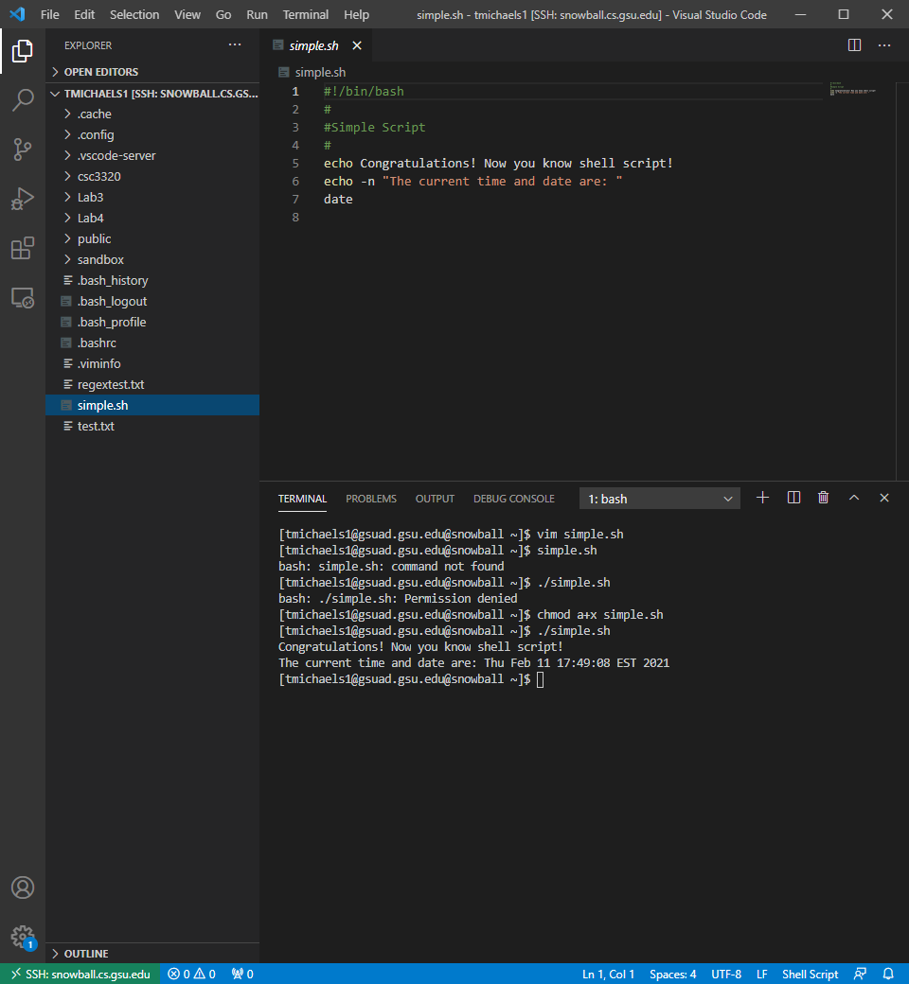

Question 4) description says to no output trailing newline. This means that there is no newline character at the end of the line so that the next command ‘date’ will print on the same line as the output from the ‘echo -n’ command

Question 5) Yes, it is a comment

Question 6) No, it is not a comment, it is telling which shell is to be used

Part 2

Question 7) there are 8 paths currently stored in the PATH variable

Question 8) There were no errors. ./ is no longer need to let the shell know where to look for the script since we added it to the path the shell will look in each location of the path for the script until it is found

Question 9) no, it is no longer there

Question 10) yes, command not found error since the path for the home directory is no longer in the PATH variable I would need to tell the shell where to look for the script by using ./

Part 3

Yes,

./checkError.sh: line 1: 1/bin/bash: No such file or directory

./checkError.sh: line 2: /1: Permission denied

./checkError.sh: line 20: warning: here-document at line 7 delimited by end-of-file (wanted `END')

Errors -> Correction

Line 1: $#/bin/bash -> #!/bin/bash

Corrected the way to tell which shell to use

Line 3: /\* Check Error Script \*/ -> # Check Error Script

Corrected comment format

Line 10: grep ‘^[^a]\*ce$’ << END >> Result -> grep -E ‘^[^a]\*ce$’ << EOF >> Result.txt

Changed to using extended grep so meta characters are used properly, changed end to EOF for simplicity, changed Result to Result.txt but only to differentiate the file from the first

Line 16: -ENDHERE -> EOF

Changed to EOF to match beginning token

Line 21: ls mail $1 < Result -> mail [$1@student.gsu.edu](mailto:$1@student.gsu.edu) < Result.txt

Removed list command, added domain for email address

Corrected

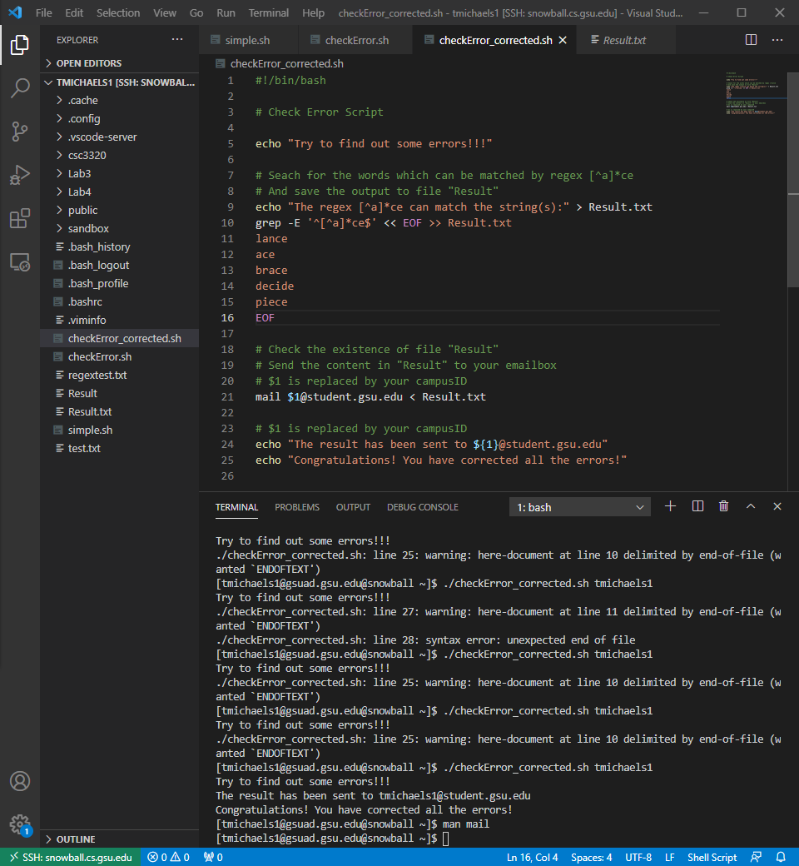

Email received

